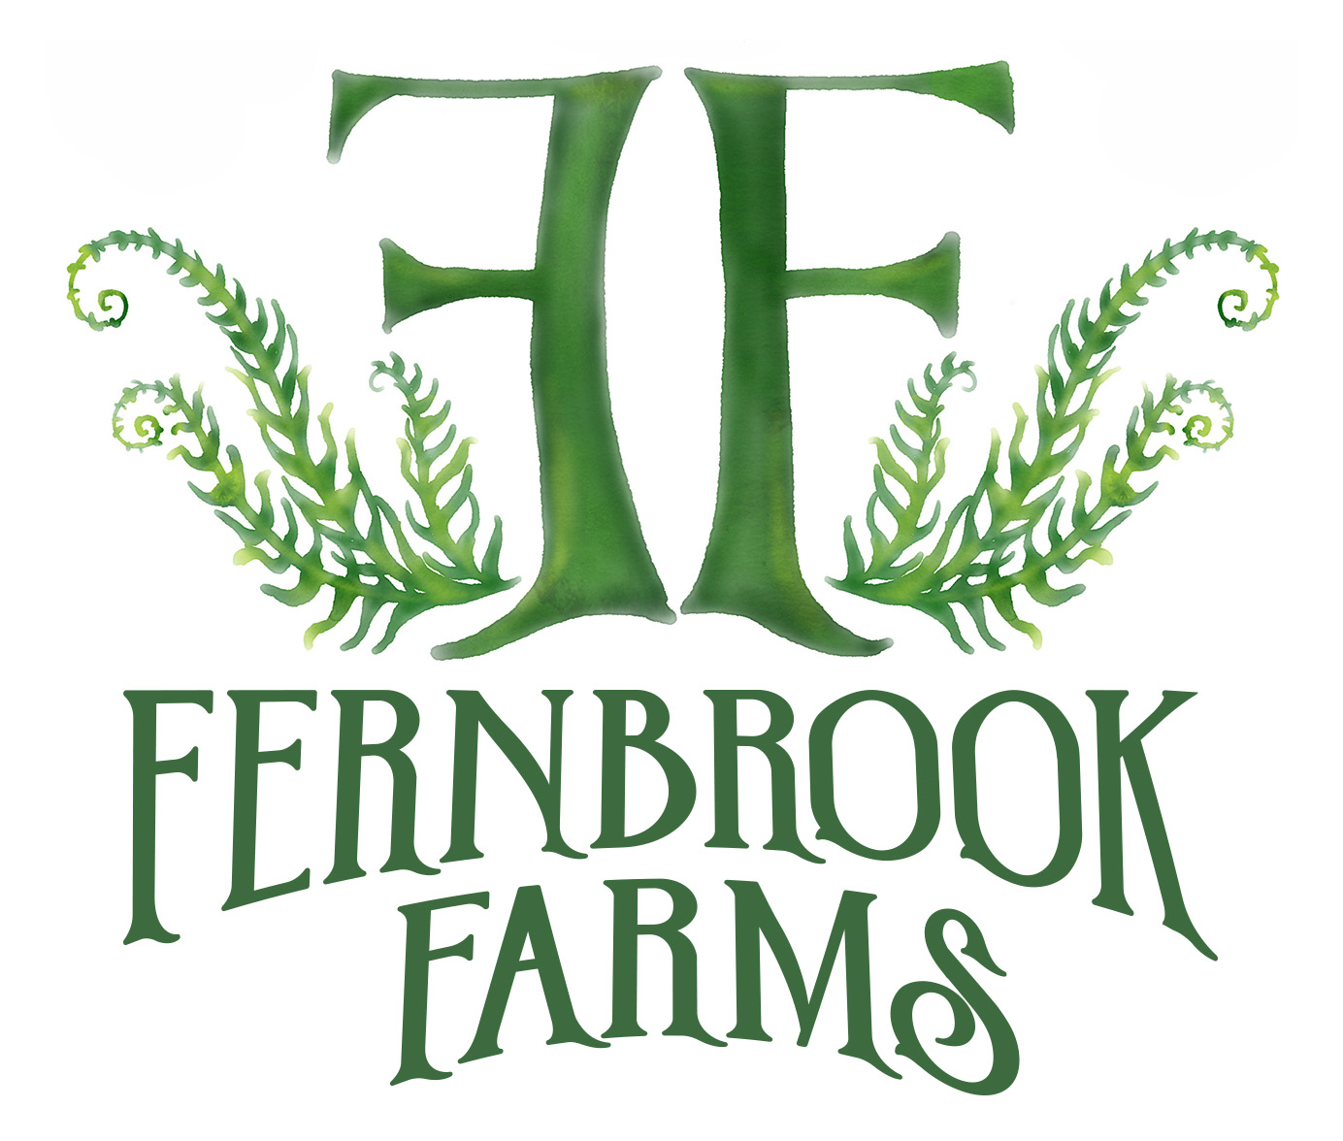 | Tomato, Herb, Veggie Sale List 2020  All proceeds from our Plant, Tomato, & Herb Sale  help support our unique programs, care for our animals, expand facilities, provide scholarships, and create unforgettable experiences for kids in nature.  Open to the Public (May 2nd to May 17th)  Saturdays & Sundays 8am-1pm  Monday-Friday 10 am-2 pm  www.FernbrookFarms.com
Cherry Varieties (2 oz. or less)
Black Opal—1/2” each; dark red/black; indeterminate.
Tangy and sweet, this black cherry tomato is sure to please! Prolific and delicious!

Bumble Bee Purple – Artisan Series; purple with green stripes; indeterminate
The Bumble Bee series of cherry tomatoes is sure to create excitement with its extraordinary beauty and superb flavor. Great for fresh tomato, basil, mozzarella and balsamic vinegar salads. Vigorous vines produce continuously over a long growing season.

Bumble Bee Sunrise- Modern Heirloom; .75 oz each; red/yellow/orange stripes; indeterminate
Very colorful! Oblong fruits are striped with bright colors. Sweet and beautiful, a great addition to a caprese salad.

Chocolate Cherry – measures 1” in diameter, chocolate-red; indeterminate
Extremely flavorful, uniform, & round. Can be picked several days before completely mature. Great variety for home gardener.

Christmas Grapes- 1.5-2 oz each; bright red; indeterminate
Easy to grow and extremely rewarding, this little cherry produces lots of fruit in grape-like clusters.

Lemon Drop— Indeterminate, cherries
These sunshine-yellow fruits have a pure, tart-sweet taste that stands up alongside the most robust salad ingredients. Heavy trusses of 3/4" fruits literally beg to be harvested and enjoyed.
Mexico Midget –Mexican Heirloom; .5 oz; bright red
Good, intense tomato flavor packed into a tiny bite! Great for salads!

Mint Julep—Michael Pollan; .5-1oz; yellow-green striped; indeterminate
Also known as Michael Pollan. Unique plum/pear shaped, 1-1/2 oz. fruits have a pleasant tomato taste with a nice overall sweet flavor that is less tart than other green varieties. Extremely high yields with one plant often producing as much as 5 gallons of fruit! Indeterminate

Red Robin- Heirloom; .75 oz.; bright red; indeterminate
This teeny tiny tasty tomato plant can be grown in hanging baskets or even an 8” pot!

Rosella- .5 oz.; red/purple; indeterminate
Round, dark red fruit that are balanced with sweetness and acidity—great for paste, grilling, or eating fresh.

Sugar Lump- German Heirloom; 1” diameter; deep red; indeterminate
Heavy yields straight through frost, a tasty and sweet cherry variety.

Sungold- hybrid; .75 oz; yellow; indeterminate
Deliciously sweet and tart round yellow-orange fruits; a Fernbrook CSA Favorite!

Tiny Tim- English Heirloom (1945); bright red; 1-2 oz fruit; determinate
This tiny wonder produces a good-sized crop on a small plant that can be grown in a 12” pot, or in a small garden.

Tumbling Tom Yellow- Open Pollinated; 1-2 oz fruit; bright yellow; determinate trailing
The yellow version of Tumbling Tom, this yellow cherry makes a tasty and interesting addition to hanging baskets.

Small Varieties (3-5 oz.)

Bloody Butcher—4 oz.; red; indeterminate
A great early variety, matures in about 60 days (but you won’t miss out on the tomato flavor)! Small round fruits are great for canning.

Green Zebra- 2 to 4 oz. Indeterminate.
(LB) This is the most unusual variety you'll ever grow! Fully ripened fruits are bright green, with stripes of a still lighter green. Round, smallish, fruits have excellent, "real tomato" flavor. Plants are vigorous.
Japanese Black Trifele—Russian Heirloom; 4-6 oz; Reddish/Purple; indeterminate
Dark red/purple fruit on a smaller plant. Great, rich flavor. Highly recommended!

Jaune Flammee – French Heirloom; 3oz fruit; yellowish-orange; indeterminate
Sweet and fruity flavor! Like a grown-up Sungold with larger apricot-sized fruits. 1.5-2” fruit hang in neat clusters. A terrifc sald tomatoe that is also great for roasting or drying!

Jersey Devil—Heirloom, Bright Red, Indeterminate. Extremely prolific, paste type heirloom shaped like a banana pepper. Pendulant fruits grow to about 5-6” are very juicy, meaty and have few seeds. Very flavorful and excellent used in sauces and salsas.

Moonglow— American Heirloom; 4 oz fruit; bright orange; determinate
Rich and fruity, golden orange fruit! Claimed by many to be the best tasting orange fruit! Great slicers.

Roma — Heirloom; 5 oz.; red; determinate
The classic paste tomato, this tasty tomato has stood the test of time. Great for canning, paste, salsas, and more. This variety is resistant to
Verticillium wilt & Fusarium wilt

San Marzano – Italian Heirloom; 5 – 6 oz.: Red; indeterminate
Compact and prolific plant from Italy. Bright red, slim, plumtype fruit over a long season Paste tomato with pointy end, heavy walls and little juice or seeds – Crack resistant.

Skyreacher--Indeterminate. A prominent stand-out in the garden. Excellent flavored, very pretty, small round slicer with a beautiful red and orange striped exterior. Strong plants produce enormous yields of blemish-free and crack resistant fruits. Performs well in a variety of conditions.
Wherokowhai—dwarf variety, rugose, potato leaf dwarf plant, the first bi-colored variety offered by the “Dwarf tomato project”. Oblate fruits with yellow swirls.

Yukon Quest—Dwarf Tomato Project; 3-6 oz fruit; pink; indeterminate
This dwarf plant produces a good crop of pink, slightly ribbed tomatoes with a slightly sweet flavor. Early!

Medium Varieties (6-10 oz.)
Amish Paste – Wisconsin Heirloom; 6 – 8 oz.; Red; indeterminate
Oxheart shaped, Roma type with thick flesh and few seeds—the largest paste tomato!

Black Sea Man—Russian Heirloom; 4-8 oz; brown-black with pink; determinate
Rich and tangy, with dark skins and pink shoulders, and some green inside!

Bush Beefsteak—Heirloom; 8 oz; red; determinate
Love beefsteak tomatoes? Have a tiny garden? This dwarf plant will produce lots of perfect sandwich tomatoes.

Lime Green Salad Tomato-- 85 days, determinate — The two to five celled fruits are flavorful, two to six ounce, globe-shaped and green on dwarf plants. The inside flesh is lime green, very juicy, mild, sweet, with a slightly tart aftertaste.
We received this variety from author and tomato authority Craig LeHoullier. It was originally bred by Tom Wagner and introduced commercially by Peters' Seed Research in the mid-1980s. Although Mr. Wagner had reportedly named the variety 'Green Elf', it was renamed 'Lime Green Salad' (by Peters' ?) when it was released.

Livingston’s Dwarf Stone-- Dwarf Stone, tree-type
The compact plants have sparse, rugose leaf foliage, and produce attractive, smooth fruit. Very prolific and the fruits ripen evenly. The fruit is larger than 'Dwarf Champion' but slightly smaller than standard 'Stone'. Introduced by the Livingston Seed Company in 1902, here is how the announced it in their seed catalog: "We consider this one of our best introductions, and, in our judgment, based on extended experience, one that will meet with general favor; especially will this be true with the class of growers whose gardening is limited to a few acres and where economy in saving land must be taken into account. The strong, upright habit of growth of Livingston's New DWARF Stone admits of very close planting, at least a half closer each way than the distance required for the ordinary vining varieties. In small gardens the plants may be set 18 X 24 inches apart each way and yet produce an abundant crop. The shape of the fruit is very desirable and beautifully smooth, with a good skin, which is free from cracks about the stem end. It is very solid, ripens very evenly, and is of most excellent quality."

Medium Varieties Continued…

Marglobe—Heirloom; 7-9 oz; Red; determinate
Naturally disease resistant and a high yielder, this versatile tomato holds up for fresh eating or canning.

Nepal—Himalayan Mountains; 6-10 oz; red; indeterminate
Smooth, round and red, this tomato has a classic look and a sweet, rich flavor.

Paul Robeson- Russian Heirloom; 7-10 oz; black/deep red; Indeterminate.
Sweet and smoky, a distinctive flavor that is a favorite among tomato connoisseurs. Inside is almost beet-colored!

Pink Berkeley Tie Dye—Modern Heirloom; 8-10 oz; burgundy with metallic green stripes
Compact plants produce beautiful fruit with a sweet, rich, dark tomato flavor. Large beefsteak fruits are the color of port wine with metallic green stripes. Its excellent sweet flavor was put to the test against Cherokee Purple in farmers markets taste tests and was preferred every time.

Purple Russian—Russian Heirloom; 5-7 oz; purple/red/black; indeterminate
AKA Ukrainian Purple. Regular leafed plant with wispy foliage, produces huge amounts of purple red, 3-4” oblong (plum-shaped) tomatoes with a blemish-free skin and excellent sweet flavor. A perfect tomato for enjoying in salads, for making fabulous tomato sauce or salsa, or canning.

Russian Swirl—Dwarf Tomato Project; 4-12 oz; yellow with red swirls
Well balanced, tasty flavor is comparable to other bi-colored varieties, but on a dwarf plant! Great for small gardens.

Rutgers – 1934 Heirloom; 8 oz.; Red; indeterminate
Very smooth, round globe with unique tangy flavor. Thick walled and crack-resistant, juicy & also a great late season producer.

Sausage-- Indeterminate An unusually-shaped tomato with fruits up to 6" long, like huge, red banana peppers. A prolific paste tomato, with very fine-flavored meat that is especially ideal for ketchup or sauces.

Speckled Roman-- indeterminate
The regular leaf plants are very productive. The paste-type fruits are elongated, pointed, red streaked with orange in color, weigh three to six ounces, and are good flavored. 'Speckled Roman', also known as 'Spotted Roman', was developed by seed saver, John Swenson of Illinois (IL SW J) from a stabilized cross of 'Antique Roman' and 'Banana Legs'.

Striped Stuffer—Modern O.P.; 5-7 oz; red/yellow stripes; indeterminate
These tomatoes are shaped like bell peppers! Medium sized, bi-colored fruits are hollow and perfect for stuffing!

Tasmanian Chocolate -- Dwarf- determinate, 8 to 12 oz
A unique class of dwarf tomatoes! Sturdy, 2 to 3 foot plants, with dark green rugose foliage, produce large, beefsteak type fruits that ripen to a beautiful mahogany red. Full of delicious, balanced flavor and perfect for eating fresh or cooked. A cross between New Big Dwarf and Paul Robeson. Great for small spaces and containers.

Large Varieties (more than 10 oz.)

Abraham Lincoln Original—10 oz.; dark red; indeterminate
Smooth, round fruit is ideal for ketchup, juice, or slicing. Sweet & solid.

Amana Orange – 2 pounds; yellow-orange; indeterminate
Huge heirloom beefsteak tomato name for the Amana Colonies in Iowa. Plants produce above average amount of beautiful light orange, irregular shaped (fluted) heirloom tomatoes that can grow to be 2 pounds or more, with an average diameter of 5 inches. Excellent sweet, almost tropical fruit flavors.

Ananas Noire- modern Heirloom; 1-2 lbs; streaked pink, yellow & green
This “Black Pineapple” is hardly black—it bears large fruit with a bright tie-dyed interior streaked with pink, yellow, and green.

Anna Russian- Russian Heirloom; 8 oz-1lb; pink/red
This oxheart variety is packed with flavor! High yields on beautiful feathery foliage make this a favorite of many tomato enthusiasts.

Aunt Ruby’s German Green-- Heirloom green, 12 to 16 oz., Indeterminate
A beefsteak with a deliciously sweet flavor that's enhanced by a spicy undertone. Globe-shaped fruits are smooth skinned, with light green skins at maturity and just a hint of yellow. Flesh is green blushed with pink, meaty, and flavorful. Makes interesting juice!
Beauty King—Indeterminate, up to 20 oz!
Possibly one of the best looking and tasting, red and yellow bicolor striped tomatoes you'll ever try! Very sweet fruits can grow up to 20 ounces each and have meaty yellow flesh with bright red streaks. A cross between Big Rainbow and Green Zebra.
Large Varieties Continued…

Beefsteak – late 1800’s Heirloom; 15 oz.; Red; indeterminate
Flattened globe shape, with large fruit. This old-fashioned favorite is meaty with small pulp cavity, making it ideal for sandwiches & fresh
eating.

Black Brandywine- 1920’s Heirloom; blackish-purple
Extra large tomato, deep, earthy and sweet flavor. A potato-leaf variety. Great for salsa and cooking!

Black From Tula-- Indeterminate A robust Russian heirloom and the largest of the dramatic blacks, with dark, greenish-black shoulders on dark, brownish-red, slightly flattened fruits that grow to 3 to 5" in diameter. Full flavored, chocolate-brown flesh with green gel is rich and satisfying. Performs well in dry conditions.
Black Krim - late 1800’s Russian Heirloom; 8 – 12 oz.; Deep maroon, almost black; indeterminate
Globe shaped fruit with the most unique salty twang in its flavor. Late Blight resistance and excellent fall crop choice.

Brandywine – 1885 Pennsylvania Dutch Heirloom; 1 – 1.5 lbs.; Red; indeterminate
Thought to be one of the best tasting of all heirlooms – Potato leaf – Excellent fall crop choice.

Caspian Pink – Russian Heirloom; 12 oz.; pink; indeterminate
The first tomato to beat Brandywine in taste tests! Originally grown in Russia between the Caspian and Black seas.

Cherokee Purple- Pre-1890 Heirloom; 12-16 oz; dusky purple-pink
Real old-time tomato flavor with large fruit and a deep purple color. Great for fresh eating.

Delicious- Heirloom, developed from beefsteak; 1-2 lbs; red; indeterminate
Smooth skinned and solid, this tomato lives up to its name. Holds the record for largest fruit (7lbs!), and growers suggest fruit of 2-3 lbs is common! Great slicer.

German Johnson Pink – U.S. Heirloom; 1 – 2 lbs.; Red to pink; indeterminate
Crack & disease resistant with mild low-acid flavor and few seeds. Huge, pink to red, beefsteak-type tomatoes are sweet and excellent for slicing and canning.

Henderson’s Pink Ponderosa – 1-2 lbs; Pink; indeterminate
Introduced in 1891 by Peter Henderson. This regular leaf plant produces moderate yields of 1-2 lb. smooth, pink beefsteak fruit with a very good flavor. Great slicing tomato with few seeds and an abundance of good, complex flavors.

Hillbilly— 1-2 lbs; yellow with red marbling; Indeterminate
This ancient heirloom hails from the hills of West Virginia, where they know a superb tomato when they see one! Huge, mild-flavored, beefsteak-type fruits weigh 1 to 2 lbs. apiece, and are colored a most unusual orange-yellow, streaked and mottled in attractive shades of red and pink. Interior flesh is practically seedless. Tomatoes are crack resistant and very heat tolerant.
Lillian’s Yellow Heirloom— 95-98 Days, Indeterminate
Magnificent, clear-yellow, globe-shaped fruits of the beefsteak-type, weighing up to 16 oz. each. Mild flesh is so rich in flavor, it actually has a creamy taste on the tongue. Vigorous, potato-leaved plants are unique in such a large-fruited, yellow variety, and provide cover for heavy yields. Local heirloom from Manchester, Tennessee.
Lucky Cross—Modern Heirloom; 8-16 oz; red and yellow; indeterminate
Looks a lot like a Brandywine in shape and size, but with red and yellow streaks. Favored among tomato enthusiasts for its sweetness and
complexity. Produces late into the season.

Mushroom Basket – 8-16 oz; watermelon-pink; indeterminate
This tomato variety originates from Russia. These large, uniquely shaped tomatoes with a delicious juicy sweet flavor. This plant produces enormous ruffled tomatoes deep watermelon-pink shade with cream-colored speckles. The flesh is firm with little gel and very few seeds, the flavor is mild and sweet. Due to the size and unique shape it is a great decorative slicing tomato and could even be stuffed.

Old German— 85 days, indeterminate — We have been growing this variety here on the farm since the early 2000s. The fruits are large, often weighing two pounds but averaging about one pound. They are golden-yellow in color with pink and red marbled throughout the flesh. The vines are vigorous and benefit from caging of staking. They tolerate heat well and have an amazingly complex flavor that makes up for their tendency to not be heavy producers. Hint: Just find room for an extra plant. Reportedly obtained from the Virginia Mennonite community, 'Old German' was released commercially by the Southern Exposure Seed Exchange back in 1985.

Orange Minsk –90 days, indeterminate — These orange beefsteak-type fruits are huge (up to thirty six ounces). They tend to have less juice than other beefsteak types and are very meaty. 'Orange Minsk' was sent to us by seed saver, Andrey Baranovski of Minsk, Belarus (BELR BA A). He told us that he obtained this Belorussian heirloom from and old woman at the Minsk Farmer's Market in 2006.

Large Varieties Continued…

Pineapple—American Heirloom; 1-2lbs.; yellow with red streaks
Fruity, low acid flavor that reminds some people of pineapples! This beefsteak type is great for slicing, with few seeds.

Polish- Polish Heirloom; 16-20oz; reddish pink; indeterminate
Excellent flavor, great for a variety of uses. Meaty! Great for canning, cooking, and slicing.

Striped German --Indeterminate ;Considered by many to be one of the most popular bicolored beefsteak tomatoes ever grown! Large 12 to 16 ounce fruits - some weighing in at almost 2 pounds! Fruit are slightly ribbed with yellow and red marbling, inside and out. A delicious beauty when sliced and also makes a great canning tomato. Meaty fruits have a complex tropical flavor and an excellent smooth texture. Heavy yielder.
Vintage Wine – Heirloom; 12 – 16 oz.; Red with stripes; indeterminate
Said to be one of the most beautiful tomatoes--Red with thin gold, green and orange vertical stripes and an acidy sharpness with smooth sweet undertones.

